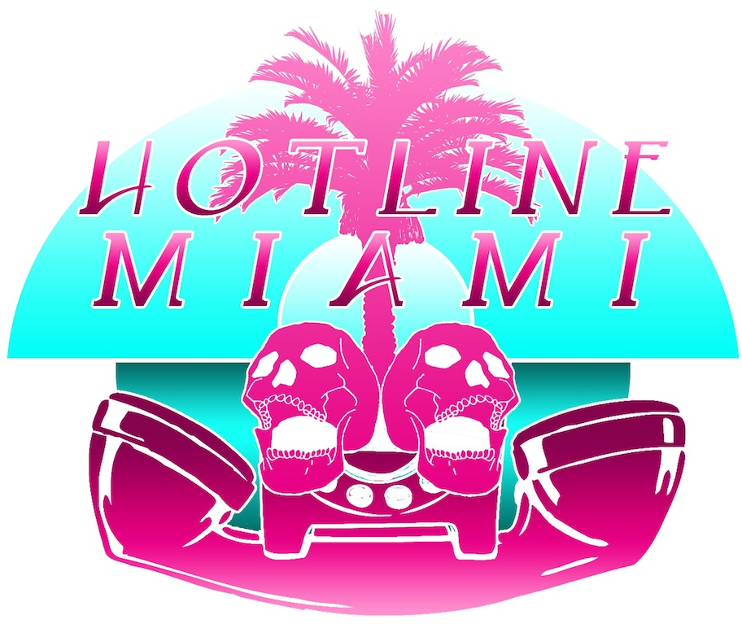

Developer Dennaton Publisher Devolver Digital

Genre Indie, Action Release Fall 2012

Platforms PC / Mac / Console Price TBD

Step into the neon-soaked underground of 1980s Miami as bizarre messages on your answering machine seem to be urging you to commit terrible acts of violence – but will you obey? Hotline Miami overflows with raw brutality and skull crushing close combat as you find yourself outgunned and using your wits to choreograph your way through impossible situations. An unmistakable visual style, a driving soundtrack, and a surreal plot that will have you question your own thirst for blood. Bash and blast through over 20 multiscreen levels with 35 unique weapons and collect 25 game-altering masks in one of the darkest and most unusual independent games on the scene.

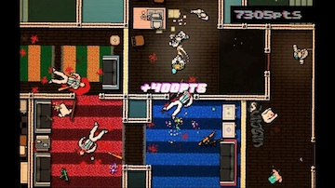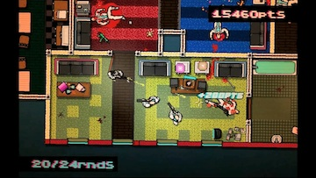

Succumb to the your bloodlust in over 20 multiscreen levels filled with the gold chain-draped thugs and the dangerous crime bosses of Miami circa 1989.

Unleash your insanity with 35 unique weapons as you run and gun through a blood-splattered gauntlet letting the adrenaline take over and guide your murderous hand.

Embrace your demons with 25 different masks – each altering your reality and changing gameplay to bring a fresh level of mayhem to each twisted mission.

Hotline Miami marks the second collaboration between Swedish game designer Jonatan Söderström and graphic artist Dennis Wedin and the first under the new Dennaton label. Jonatan Söderstrom gained notoriety in 2008 as an Independent Games Festival finalist for Clean Asia! And won the 2010 Independent Games Festival Nuovo Award for his surreal visual puzzle game Tuning. The two first collaborated on the bizarre Keyboard Drumset Fucking Werewolf.

Hotline Miami Dennaton Devolver Digital
www.hotlinemiami.com www.dennaton.com www.devolverdigital.com
@hotlinemiami @cactusquid @forkparker

Hotline Miami can be reached at +1 786 519 3708 and @HotlineMiami. Please leave a message.

